***The Tableau HR Scorecard: Measuring Success in Talent Management.***

**1.INTRODUCTION:**

1.1 Overview :

The perspective measures the satisfaction of internal and external customers of HR services, including employees, managers, and job candidates. It includes KPIs such as employee engagement, manager satisfaction with HR support, and candidate experience.

It includes KPIs such as employee skills and competencies, employee retention, and the percentage of employees who receive regular training and development.

1.2 Purpose :

The purpose of the Tableau HR Scorecard project in measuring success in talent management is to provide a comprehensive and visualized assessment of HR-related metrics and key performance indicators (KPIs).

It aims to track and analyze factors such as employee retention, recruitment effectiveness, training and development impact, and overall workforce productivity.

By utilizing Tableau's data visualization capabilities, the project helps HR professionals make informed decisions and improvements in talent management strategies for enhanced organizational performance and growth.

2. Problem Definition & Design Thinking :

2.1 Empathy Map :

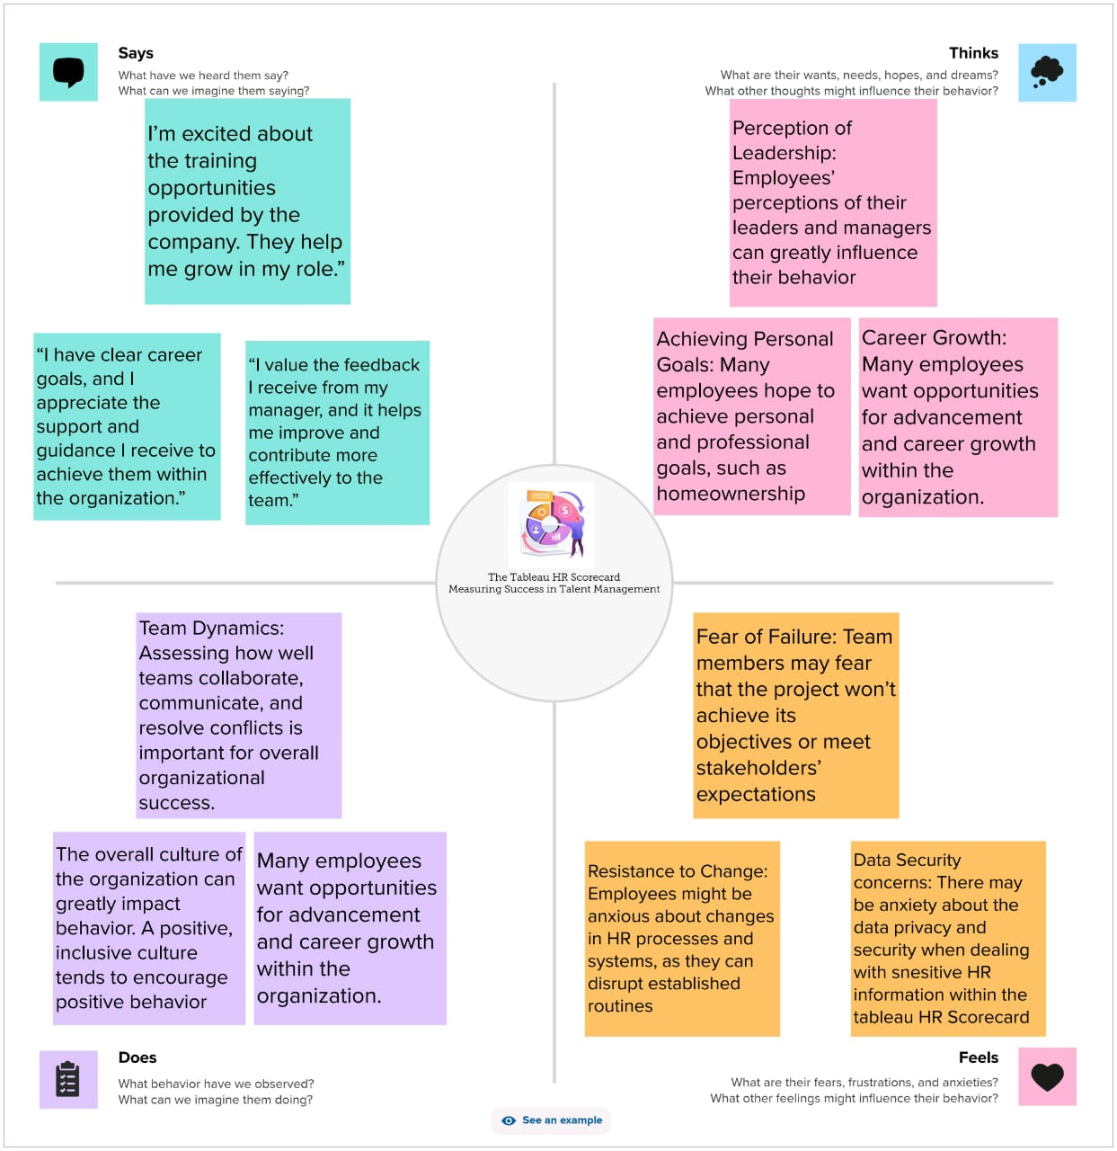

2.2 Ideation & Brainstorming Map :

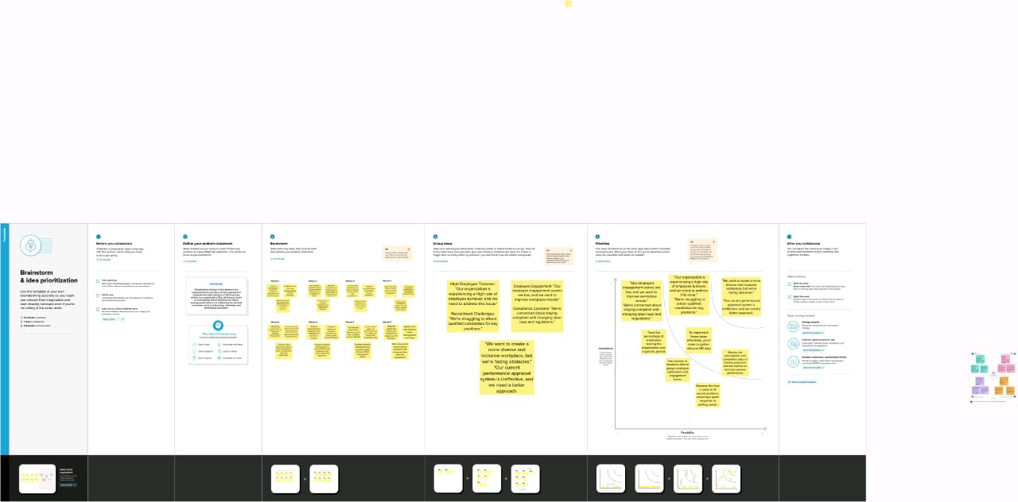

3 RESULT :

Sheet 1 :

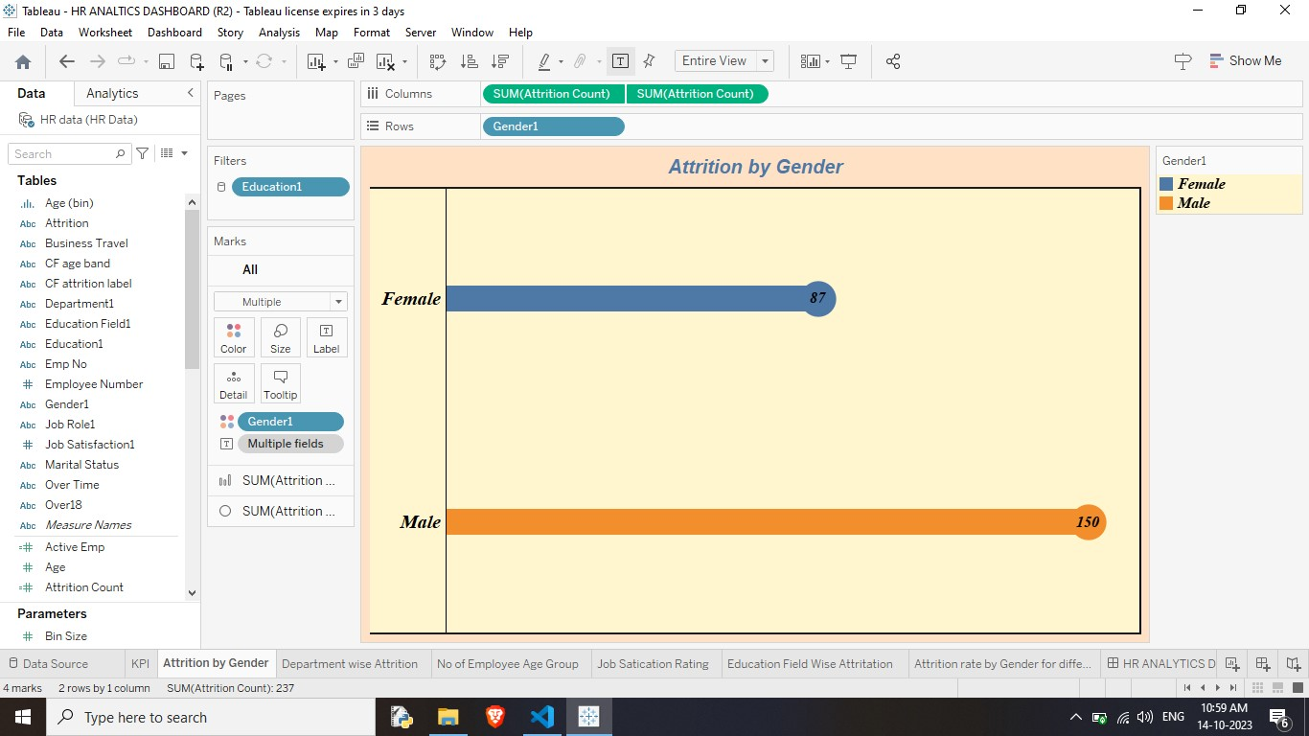

Sheet 2 :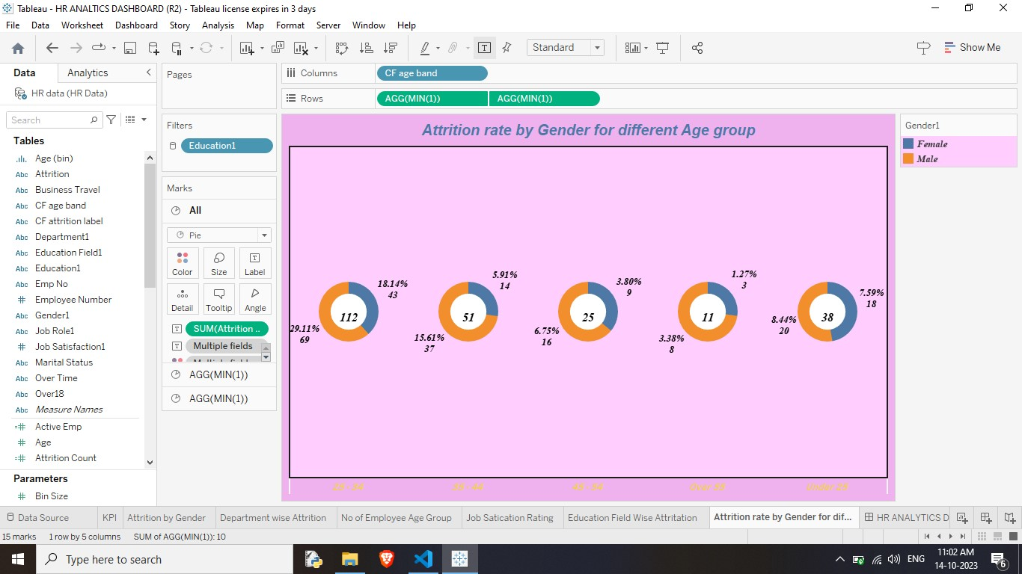Sheet 3 :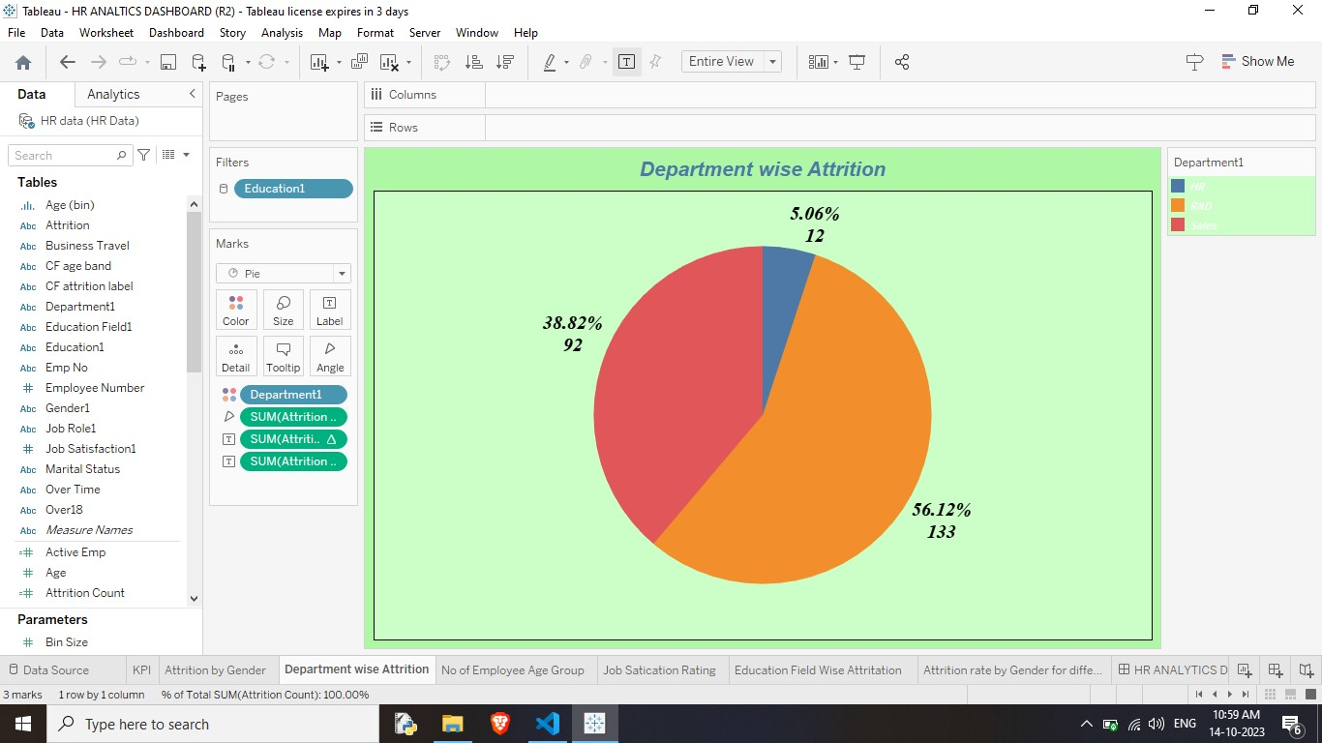

Sheet 4 :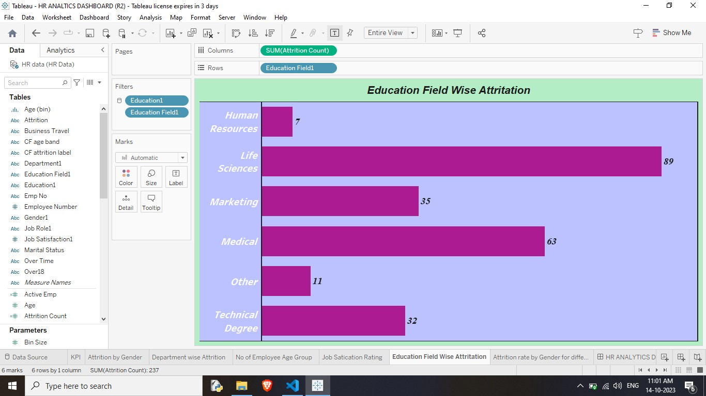

Sheet 5 :

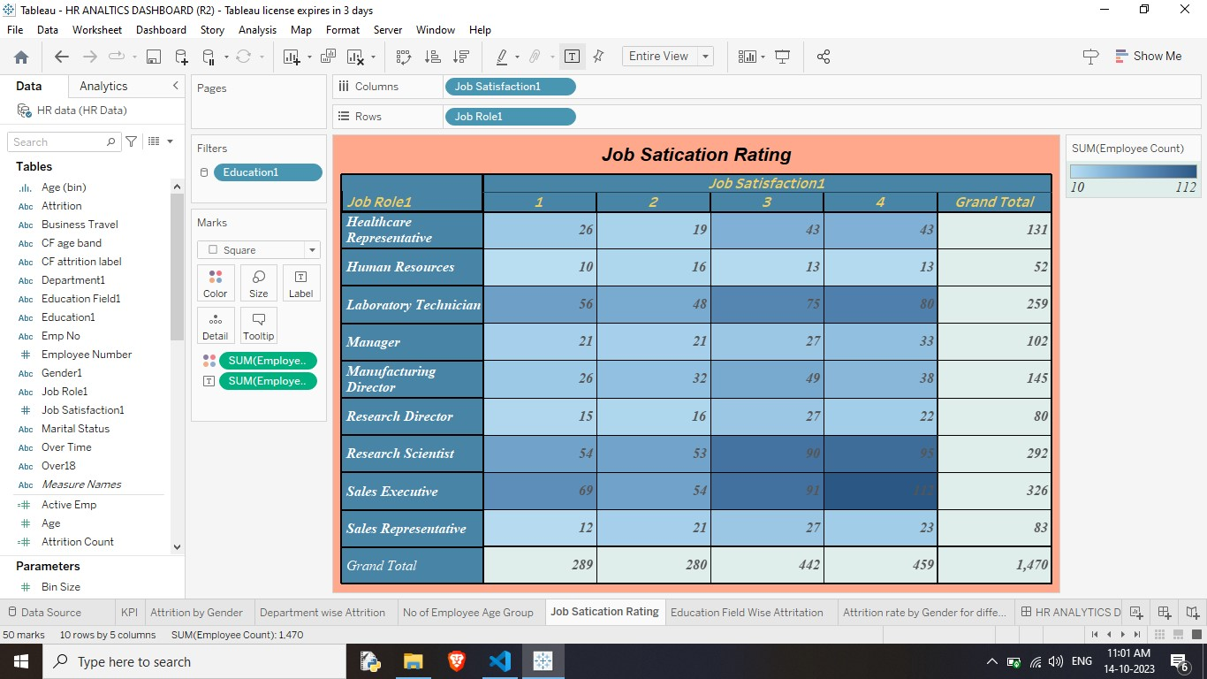

Sheet 6 :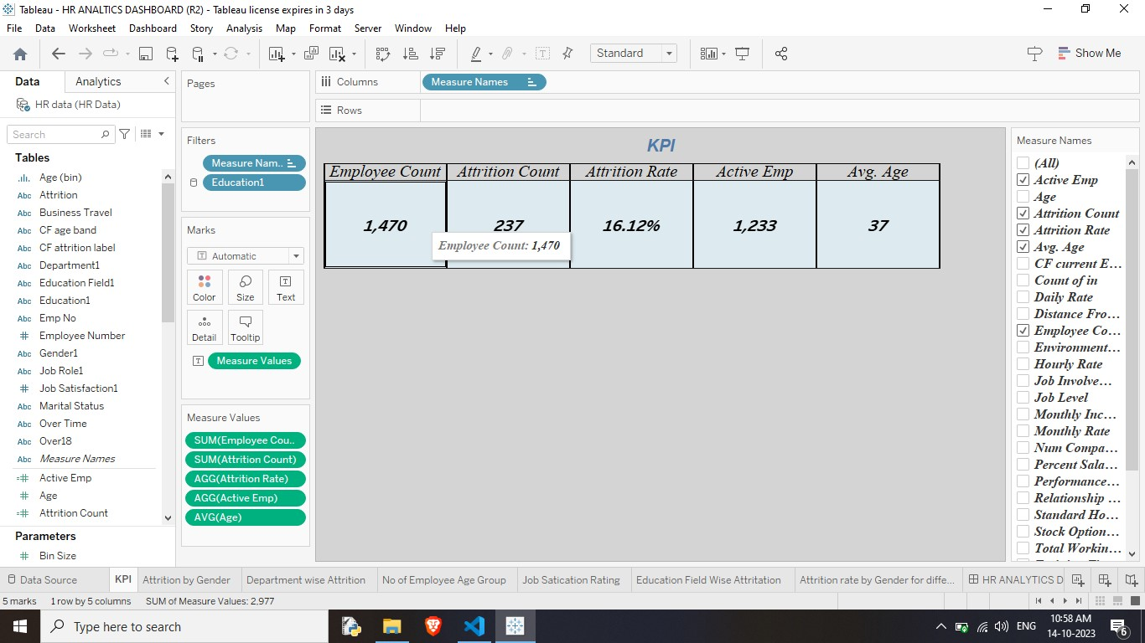

Dashboard:

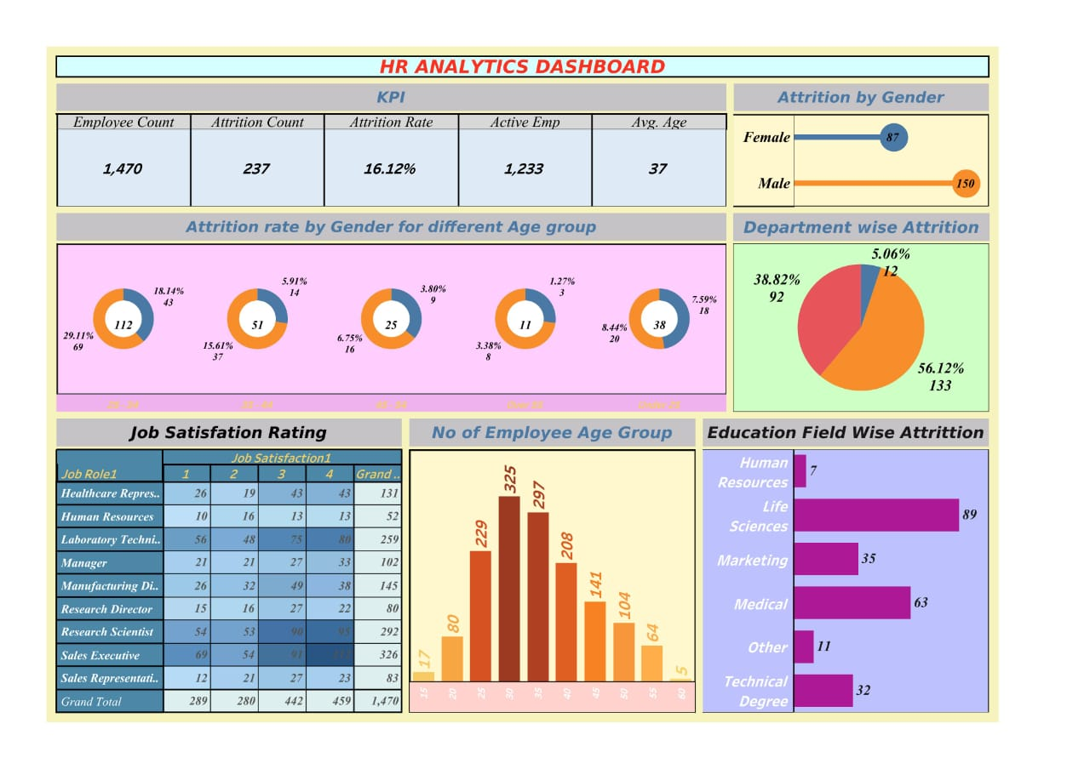

Story 1 :

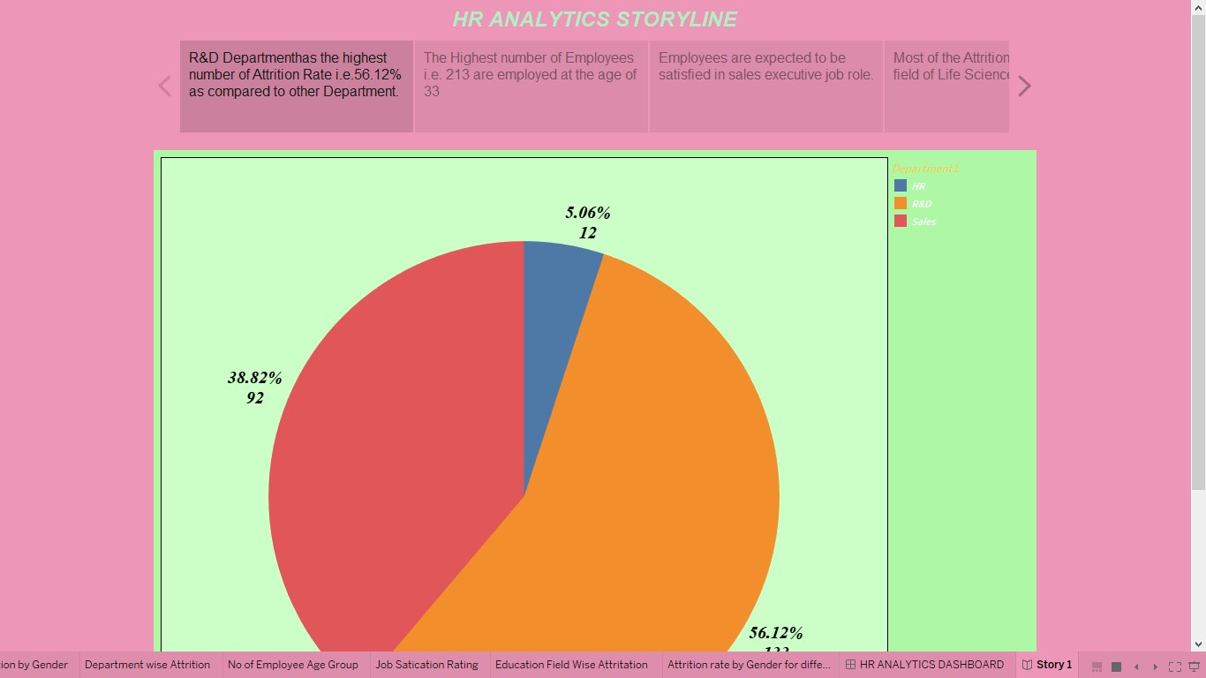

Story 2 :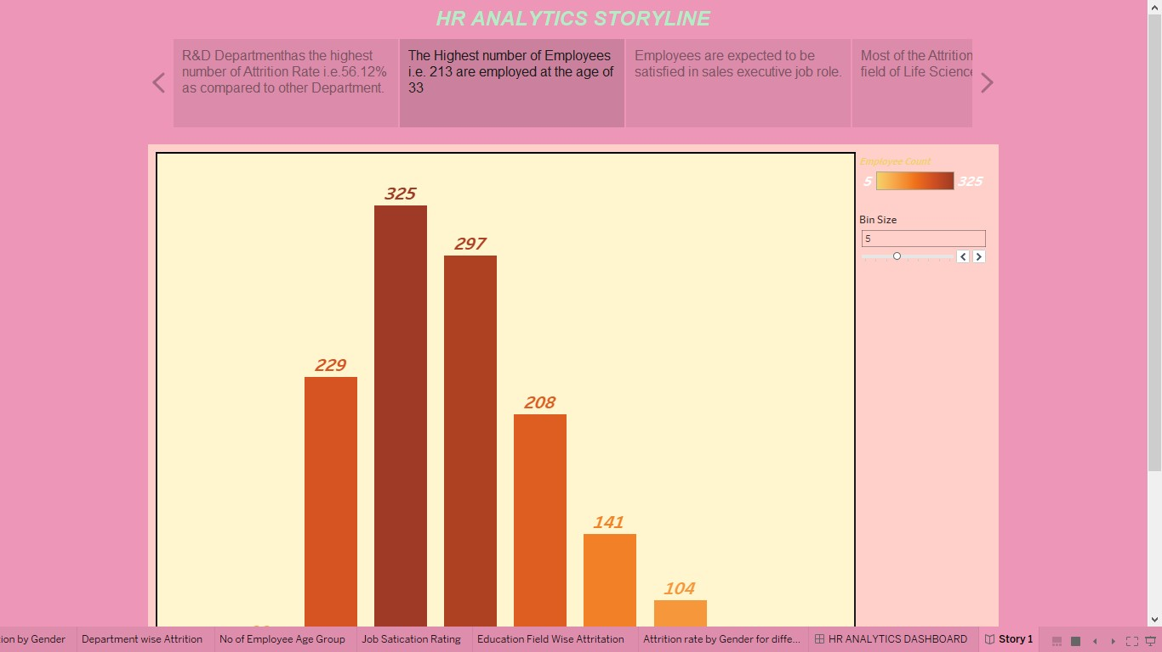

Story 3 :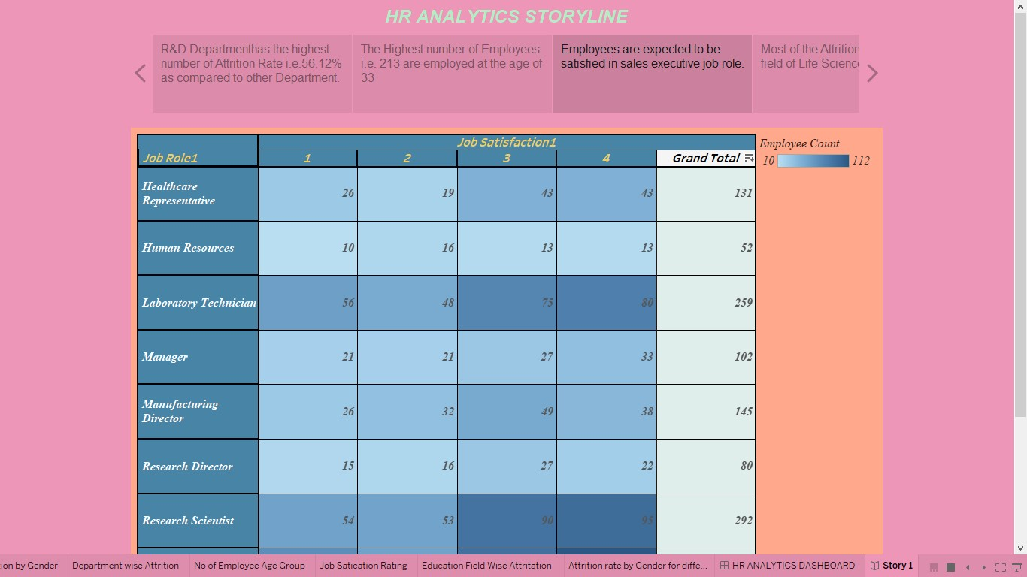story 4 :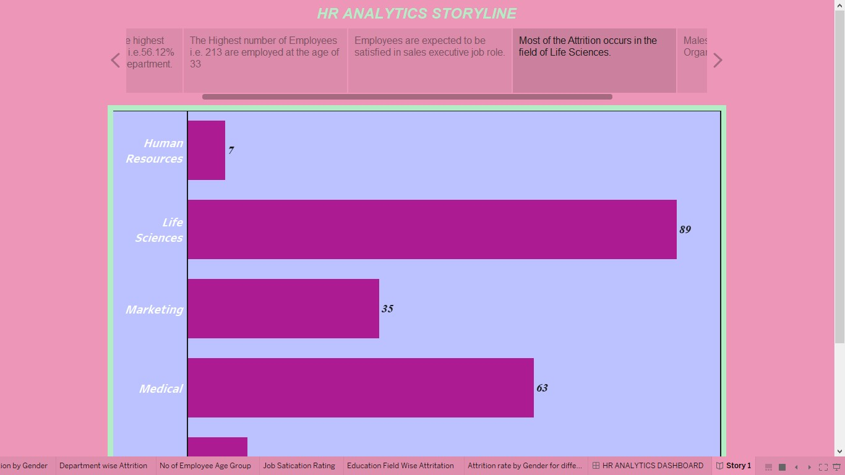

Story 5 :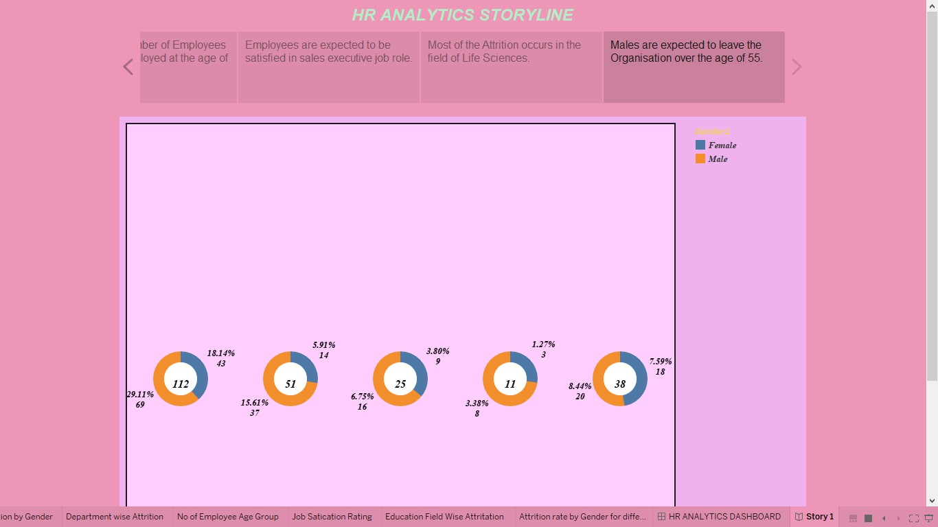

4. ADVANTAGES & DISADVANTAGES:

Advantages:

Visual Data Representation: Tableau allows HR data to be presented in visually engaging dashboards and graphs, making it easier to comprehend and analyze complex HR metrics.

Real-Time Monitoring: Tableau enables real-time tracking of talent management metrics, facilitating timely interventions and adjustments based on the latest data.

Data Integration: Tableau can integrate data from various HR systems and sources, providing a comprehensive view of talent-related data in one centralized platform.

Enhanced Communication: The visually appealing dashboards in Tableau facilitate effective communication of HR insights and performance metrics to stakeholders, fostering a shared understanding of talent management success.

Disadvantages:

Implementation Complexity: Setting up Tableau HR Scorecard can be intricate, requiring expertise and time to configure data sources, design effective dashboards, and integrate with existing systems.

Costs and Licensing: Tableau licenses and associated costs may be significant, especially for smaller businesses or organizations with limited budgets, potentially making it less accessible.

Learning Curve: Learning to use Tableau effectively demands training and time investment, particularly for users unfamiliar with the platform, which could delay implementation and productivity.

5. APPLICATIONS :

Succession Planning: Identify potential successors and create development plans to fill key roles within the organization.

Workforce Diversity and Inclusion: Analyze workforce demographics and inclusion initiatives to ensure a diverse and equitable workplace.

Retention Strategies: Analyze turnover rates and reasons for attrition to develop effective retention strategies.

Compensation and Benefits Analysis: Evaluate the competitiveness and effectiveness of compensation and benefits packages to attract and retain talent.

Strategic Workforce Planning: Align talent management strategies with organizational goals and forecast future talent needs.

6. CONCLUSION :

"The Tableau HR Scorecard: Measuring Success in Talent Management" is a highly valuable and relevant project. By leveraging Tableau, a powerful data visualization tool, and focusing on talent management success measurement, the project addresses a critical need in modern organizations.

7. FUTURE SCOPE :

Ethics and Diversity Analytics: Integration of metrics related to ethical behavior, diversity, equity, and inclusion, fostering a more inclusive workplace and promoting ethical conduct.

Integration with HR Technology Ecosystem: Seamless integration with various HR technologies such as applicant tracking systems, performance management software, and learning management systems to create a unified talent management ecosystem.

8 APPENDIX :

A. Source Code :